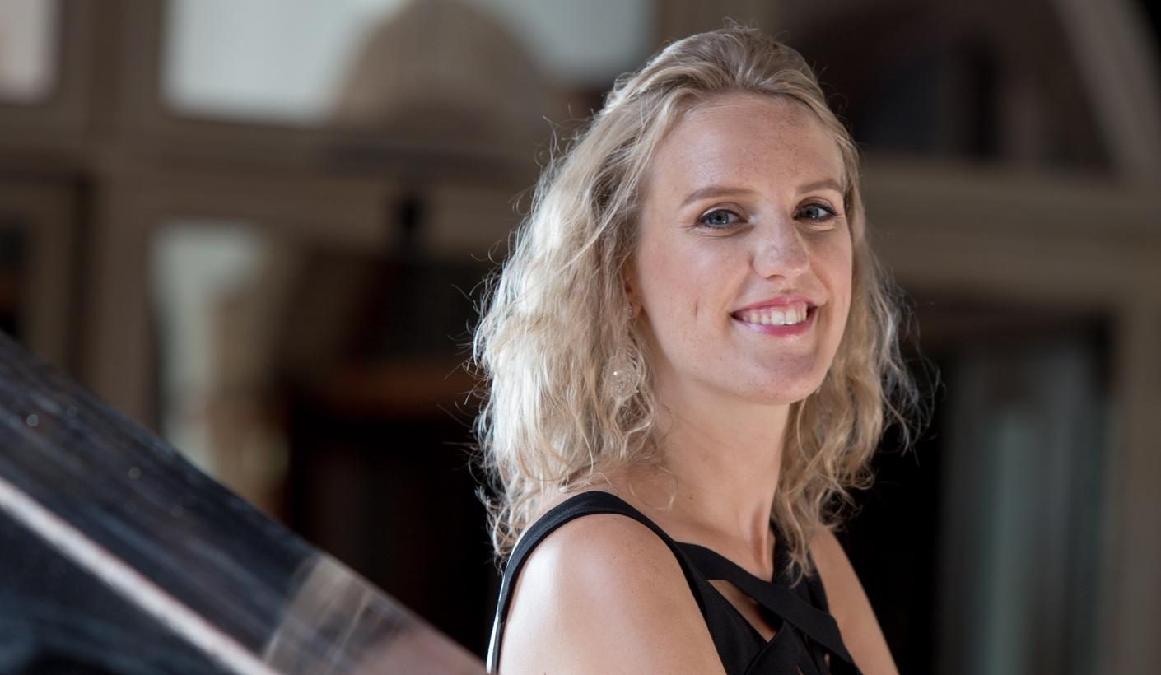
Léna Kollmeier, Belgian pianist, mastered her instrument remarkably well at an early age. This naturally led her to being accepted as a young talent by Liège Conservatoire, at the age of 15. She obtained her Master of Arts in piano with honours from Brussels Conservatoire after having studied with teachers such as Daniel Blumenthal, Pierre Thomas and Etienne Rappe. She has also actively participated masterclasses taught by Dominique Cornil, Natacha Zdobnova, Dana Protopopescu and Boyan Vodenitcharov.
At the age of 17, she won First Prize at the Dexia Classics Competition and performed a recital in the Théâtre Royal de la Monnaie in Brussels which marked the beginning of her career. She soon had the pleasure of performing with various orchestras, and has appeared as a soloist and chamber music specialist on the international stage – namely in Europe, the US, Thailand and the Caribbean in prestigious venues like the Carnegie Hall in New York, the Philharmonie in Luxembourg, El Ateneo in Madrid and the Palacio de Bellas Artes in Santo Domingo.
Léna Kollmeier is co-founder of two chamber music ensembles: the DUO ROSA, together with soprano Stephany Ortega since 2014, and the Trio O3, specialized in the contemporary repertoire formed with cellist Eugénie Defraigne and flutist Lydie Thonnard.
The duo launched their first album « Return » in 2016 in the Philharmonie Luxembourg, under the label Etcetera Records. They followed up on their release with a promotional tour - Return World Tour - across 18 cities around the world. In 2019, the duo released their second album « American Soul : from Broadway to Paris » (Hänssler Classic) which has been nominated by the International Classical Music Awards (ICMA) 2020.
In 2018, the Trio O3 won the « Supernova » competition and allowed them to go on tour to several Belgian festivals and concert halls, especially Flagey in Brussels and the Palais des Beaux-Arts in Charleroi. Léna also has a piano duo with her sister Louise Kollmeier. In 2019, the Kollmeier Sisters won a second prize at the international competition « Grand Prize Virtuoso » and performed at the Concertgebouw in Amsterdam for the occasion.

